**Ahmednagar Jilha Maratha Vidya Prasarak Samaj’s**

**NEW ARTS COMMERCE AND SCIENCE COLLEGE ,**

**PARNER**



**Department of B.B.A. (Computer Application)**

**A**

**Project**

**On**

**“Car Showroom”**

**Submitted in partial fulfillment of the requirement of the degree**

**B.B.A. (Computer Application)**

**Under the Guidance of**

**Prof.Atkar P .R**

**-: Submitted By :-**

**MR.DHIRAJ DILIP AHER**

**-:Submitted To:-**

**Savitribai Phule Pune University**

**(2021-2022)**



**CERTIFICATE**

This is to certify that **Name:- Aher Dhiraj Dilip** BBA (Computer Application) has completed the Project titled **“Car Showroom”** as per syllabus laid down by the Savitribai Phule Pune University during academic year 2021-22. he is sincere, honest and completes the work allotted to him within stipulated time.

His performance is excellent/good______________

**Internal Examiner External Examiner**

**Project Guide Head of Department**

Acknowledgement

* After complete this year project, I would like to take this chance to express my sincere gratitude to my project teacher which is mam **Prof.Atkar P .R**
* who has guided me throughout the project. When I still doing nothing while project due date is getting close, **Prof.Atkar P.R** give me some pressure to complete the project.
* Without her, I think I can’t finish the project on time. I faced a lot of problems in this project, but finally I found a particular problem solution with the help of the Internet and other reference books.
* I would like to thank her for one more time because she shared her experience with us so that we can get more logical understanding on how to develop software which is suitable for the current society.
* Finally I would also like to thank my friends who helped me a lot in finalizing this project within the limited time frame.

**INDEX**

|  |  |  |
| --- | --- | --- |
| **Sr. No.** | **Title** | **Page No.** |
| 1 | **Introduction.** |  |
|  | Introduction of system. | 5 |
|  | Scope of System. | 6 |
|  | Proposed System. | 7 |
| 2 | **System Analysis.** |  |
|  | Fact Finding Techniques. | 8 |
|  | Feasibility Study. | 9 |
|  | Hardware and Software Requirement. | 10 |
| 3 | **System Design.** |  |
|  | Entity Relationship Diagram. | 11 |
|  | System Testing | 13 |
| 4 | **File Design.** |  |
|  | File design with input values. | 18 |
| 5 | **Reports.** | 34 |
| 6 | **Advantages and Disadvantages.** | 35 |
| 7 | **Feature Enhancement.** | 36 |
| 8 | **Conclusion.** | 37 |
| 9 | **Webibliography.** | 38 |

# Introduction to System

Car Showroom is a project that is used to manage and control the complete record of Cars. This mini project is to present hold the record of Cars, Customers, corporations, booking.

This Car showroom Project is devised for owners and users who are engaged in cars. This system has the track of all the cars with every single detail. From the date of production to up to what price can one consult while taking that car, one can view all the data here. If someone is involved in buying the car, then he/she can reach the retailer as well for the same, via the system.

Scope

# Car showroom Project provides solution for showrooms for organizing data using software application. This software application helps administrator to update data in step by step process while selling car to customer.

# Using this Website can update customers information, car information, payment details, Insurance details, take orders. etc.

Objective

* Car showroom Management carries all the information related to vehicles number, controlling the position
* One-stop data of car includes engine number, registration number RC book number, and more It also can store data of legal documents like insurance road tax, user can also upload scan copy of the documents
* Daily / Weekly / Monthly alarms can be set for the future renewal of documents Location-wise user wise alert list can be configured

# Proposed website

* The proposed system is very effective. If someone is interested in buying any car, then he/she can check all the information related to the car in the given portal.
* He/she can even book the test drive within the system. The proposed system also helps the buyer to check which cars and companies are good for them, by showing them the past reviews

Fact Finding Technique

* To develop any website the user needs to do collects facts and all the relevant information. The success of any project depends upon the accuracy of available data.
* Fact Finding is the formal process of using research, interviews, questionnaires and other techniques to collect information about website.

Interviews:-

* Interview is the best method for producing qualitative information such as opinions, policies, subjective descriptions of activities and problems.
* Interviews are strong medium to collect requirements from individuals or from group.
* In this method, the analyst sits face to face with the people and records their responses.

Record View:-

* Records and reports are the collection of information and data about the website and its operations.
* The information related to the website is available in documents, newspapers, magazines, journals, electronic media etc.

Feasibility Study

* Feasibility is the practical extent to which a project can be performed successfully.
* The objective / goal of the feasibility study is to establish the reason for developing the website that is acceptable to users, adaptable to change and comfortable to established standards.
* **Technical Feasibility**
* Technical feasibility refers to the technical resources needed to develop, purchase, or operate the website.
* Technical feasibility assesses the current resources and technology, which are required to accomplish user requirements in the website within the allocated time and budget.
* **Operational Feasibility**
* Determines whether the problems anticipated in user requirements are the high priority.
* Determines whether the solution suggested by the website development team is acceptable.
* **Economic Feasibility**
* It determines whether the required website is capable of generating financial gains for an organization.
* Cost required to conduct full website investigation.

**Hardware and Software Requirement:-**

* **Hardware Requirement:-**
* Processor: Pentium p4 and Above
* Main Memory: Minimum 1 GB RAM
* Hard Disk:4 GB and Above

* **Software Requirement:-**

* Operating System: Windows XP, Windows 10 etc.
* Front-End: HTML, CSS, JavaScript and Bootstrap.

Entity Relationship Diagram

Authentication 

Login

Mobile

Admin

customer

Keep

Track

**File Design with input values**

**Login**

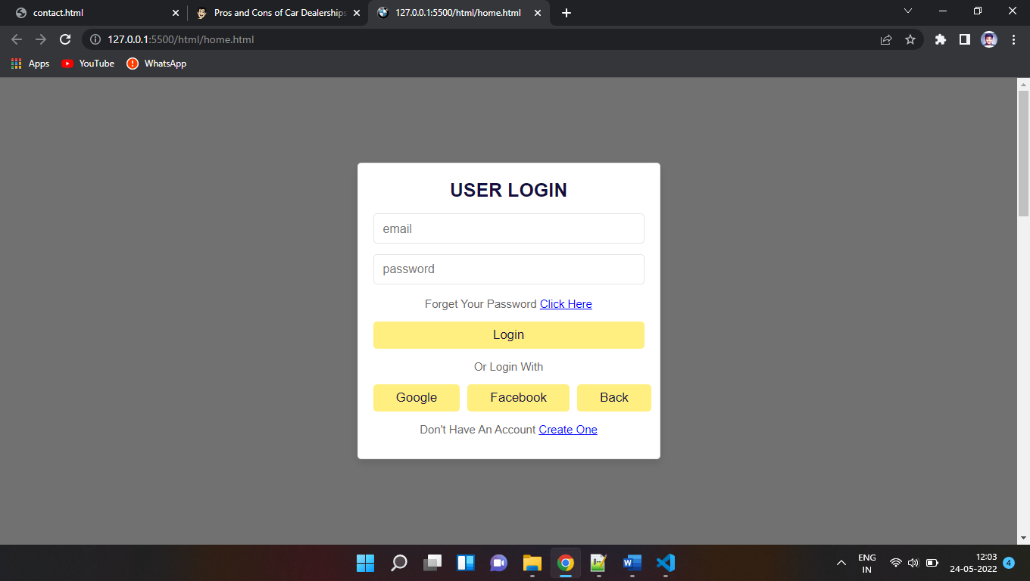

**Home**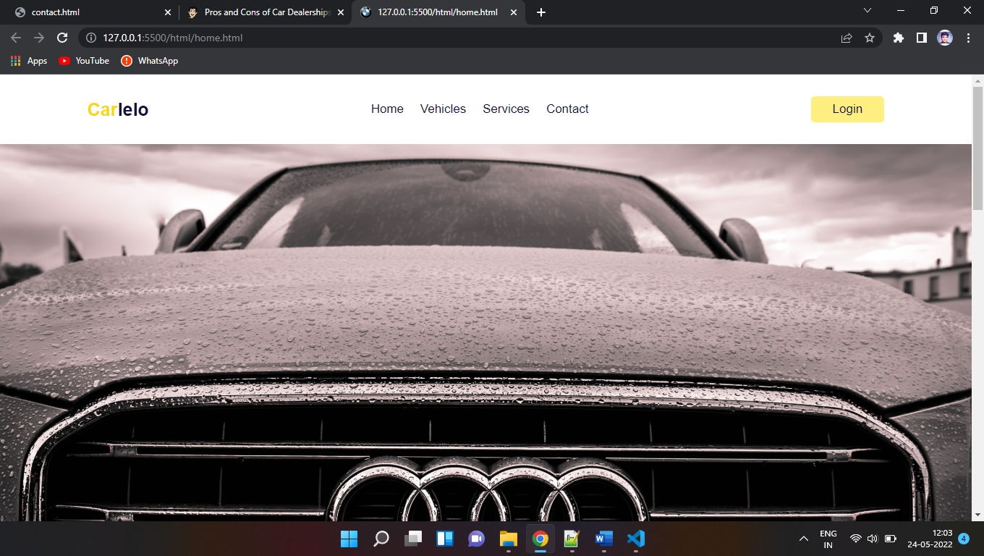

**Vehicles**

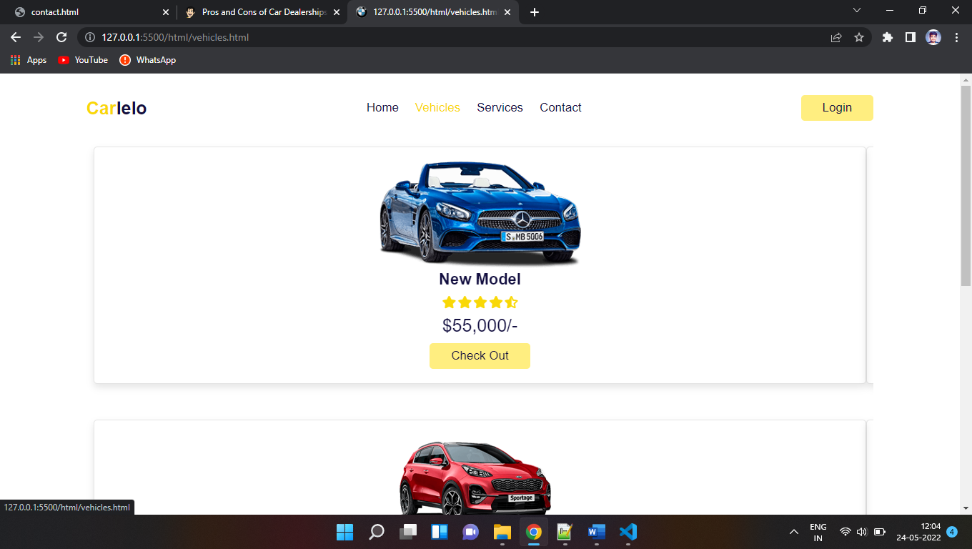

**Services**

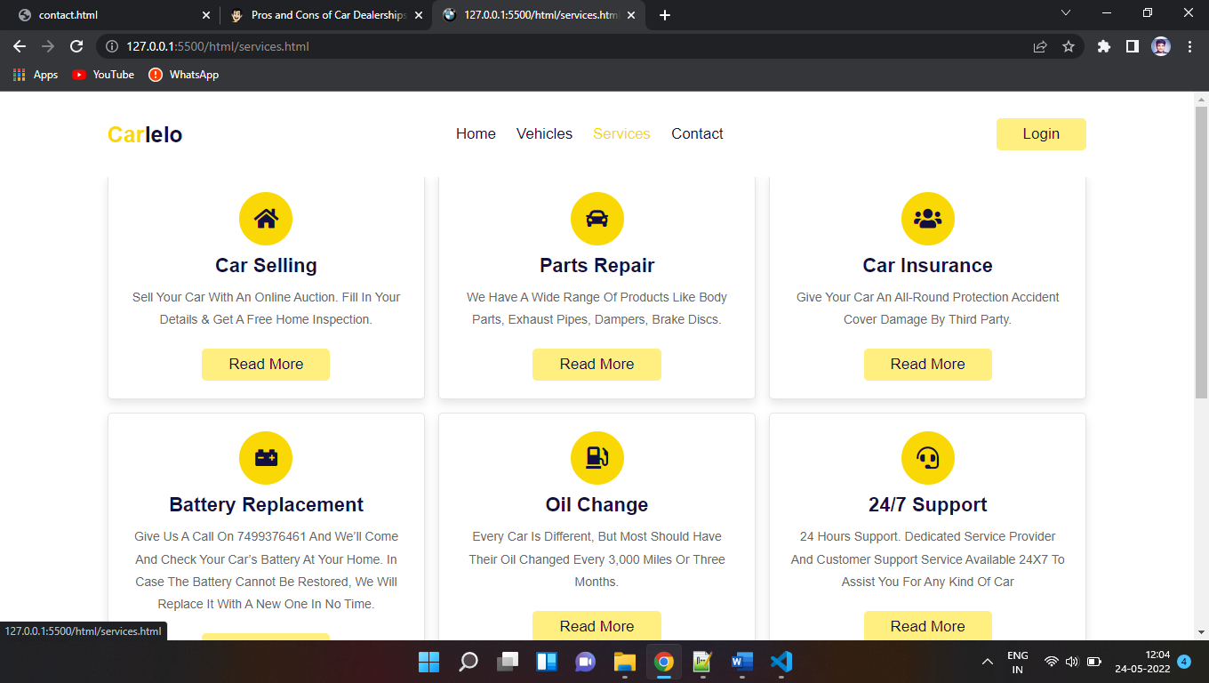

**Contact**

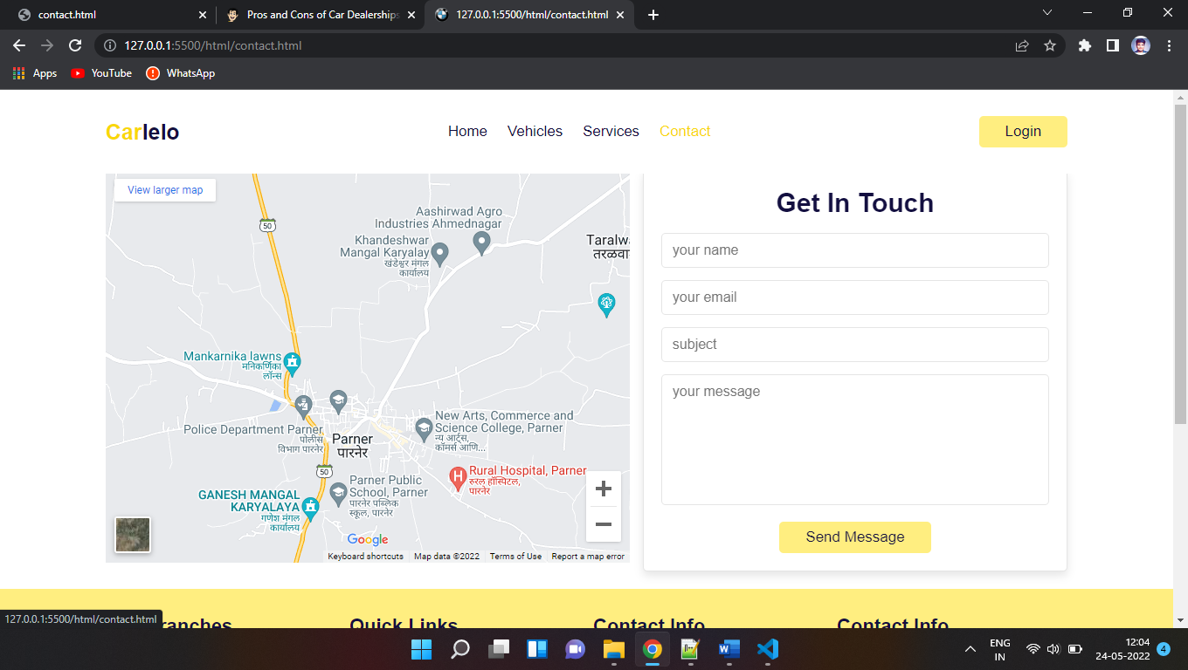

**Footer**

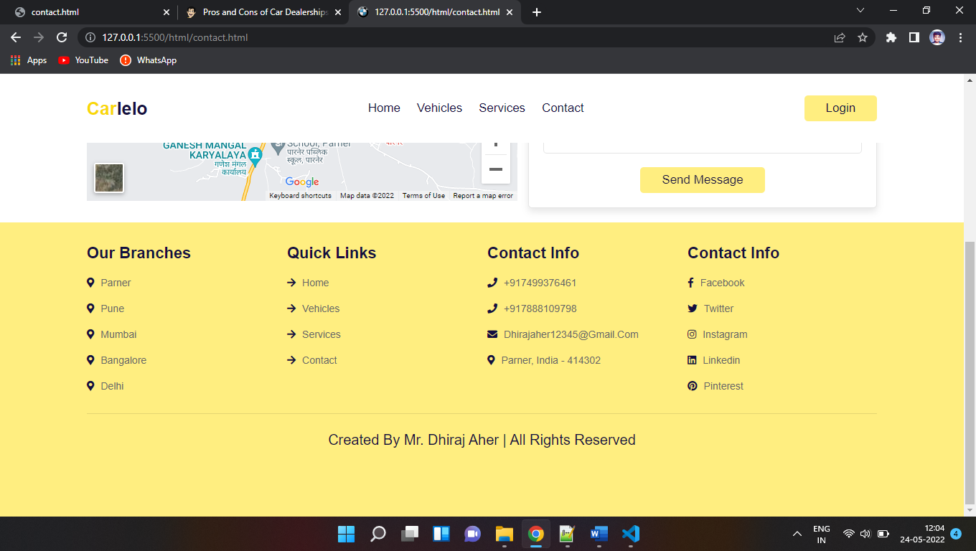

**Reports:-**

* Project Study-The primary purpose of the Car Showroom website Project is the discipline of the planning, coordination, and management of the Shop’s activities.
* Our project aims to make the work of the Shop easier car Administration joins the archives with the website and gathers the content available in the Coffee Shop.
* In This project, Admin can modify the Menu and Products details as well as keep record maintainable and secure.

**Advantages:-**

* Dealerships of today are designed for comfort, convenience and efficiency in an effort to provide an optimum buying experience for the customer. From shuttle service, comfortable lounges with Wi-Fi access and drive-thru service bays to mobile optimized websites, car-care clinics and service-appointment reminders — all points of contact are meant to provide value to customers. Plus, when a vehicle is serviced at a dealership, any warranty
* Many consumers are surprised to learn that dealerships are also in the collision repair business (servicing all makes and models). Dealerships either have a collision repair shop on site or they are affiliated with a reputable shop nearby. If you are involved in a collision, it’s your legal right to choose where you want your vehicle repaired.

**Disadvantages:-**

* With franchising, you are constrained to the pre-established model of business.
* With private dealerships, you are constrained by your financial backing.
* As a general business person, opening a car dealership might incur losses, especially if you know little to nothing about this type of business.
* Franchising can be expensive, as you must pay upfront for the business and are also required to pay a franchising fee.
* Hiring the wrong salesperson might be bad for business as it can only be as good as the sales it makes
* Franchising limits you to one car brand, restricting the number of buyers you can get

**Feature Enhancement:-**

* Car showroom carries all the information related to vehicles number, controlling the position One-stop data of car includes engine number, registration number RC book number, and more
* It also can store data of legal documents like insurance road tax, user can also upload scan copy of the documents
* Daily / Weekly / Monthly alarms can be set for the future renewal of documents Location-wise user wise alert list can be configured

**Conclusion:-**

This is the perfect system for the car showrooms to manage their data and help their customers to buy a car without any problem. It makes the process of buying a car very simpler.

**BIBLIOGRAPHY:-**

* Web Developing Absolute Beginner’s Guide (3rd Edition) - Dean Miller
* Mastering HTML, CSS, JavaScript web publishing (1st Edition) - Nirali Prakashan

**WEBLIOGRAPHY:-**

* -http://www.google.com
* -http://www.w3school.com
* -http://www.tutorialspoint.com